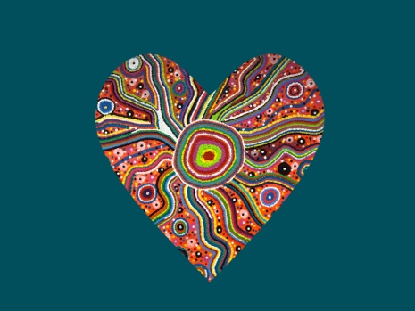

The HeARTlands of Brisbane brings Aboriginal and Non-Aboriginal community together to embrace Social Inclusion Week featuring a pop-up art exhibition extravaganza of artwork created by over 50 artists, performances by local musicians and thought provoking roving theatre to connect, collaborate and celebrate. The exhibition is curated to 4 key areas: Aboriginal Art, Street Art, Community Art, and Youth Art.
The vision of the exhibition aims to bring community together and use art to share stories to Connect, that each artist takes responsibility to Collaborate and that greater Brisbane experience and Celebrate the amazing work of participating artists.
In this event we are also looking at presenting 4 community awards on our opening night and are looking for your nominations from your organisations. Please return this form by Friday 15th of November to kellys@communify.org.au and include in the body of email why you are nominating the person for the particular award.
Local Hero Award
Someone who stand up and is a believer for others in the community .always trying to support people in different ways ,and go the extra mile to open doors to fill all the blank gaps.
Name of Person nominated: ____________________________________________
Person nominating: ___________________________________________________
Volunteer of the Year Award
Someone who has been loyal to your organisation and who has used their gifts and abilities to contribute in a volunteer capacity for great outcomes
Name of Person nominated: ____________________________________________
Person nominating: ___________________________________________________

Local Social Inclusion Member Award
Champion of social inclusion creating opportunities for people from all backgrounds to get involved in community events
Name of Person nominated: ____________________________________________
Person nominating: ___________________________________________________
The Heartlands of Brisbane Award
My journey started with the reflection of different cultures, languages, and people. We share the community with stranger places.
I could see the deep blue ocean, where my spirit lives, I can see the mountains and waterways where our dreaming took place.
Our lives were shattered, our stories and our dreams were gone, and out futuires started to roll away. 100 years have gone and new ones begin. But I am surrounded by unbroken lies. Our rivers are gone forever. We were planted like grass in the fields. They put a boundary between themselves and us. Our songs were sang with tears in our eyes. We were divided into chains; our community was gone. Every stone turning, our ideas had changed and so had our ways of life.
WE walk in different pathways, the values of our family taught me to find and search in my heart. And I know I was given the right place, where I grew into the person I am today.
Now I live in another community, with different cultures, languages and people from other countries. I feel all Australians are included and valued, giving everyone the opportunity to participate fully in society.
We are connecting to build and strengthen relationships, and address the isolation of those who may be marginalised. I am the heart of the people who know where to find the Heartlands of Brisbane. Where the rivers run free, where I was lost and now I am found and I am accepted in my community. Because I respect my elders past and present.
Social inclusion gives me the opportunity to tell my story in my spirituality and dreaming to others in different places and languages. To share our art, music, and stories and take me to the place where my dreams can come true.
Where I can see the Heartland of Brisbane.
Uncle Gerard Bargo

Name of Person nominated: ____________________________________________
Person nominating: ___________________________________________________

